Data Analytics Assignment -2

Donut chart:

Area chart:

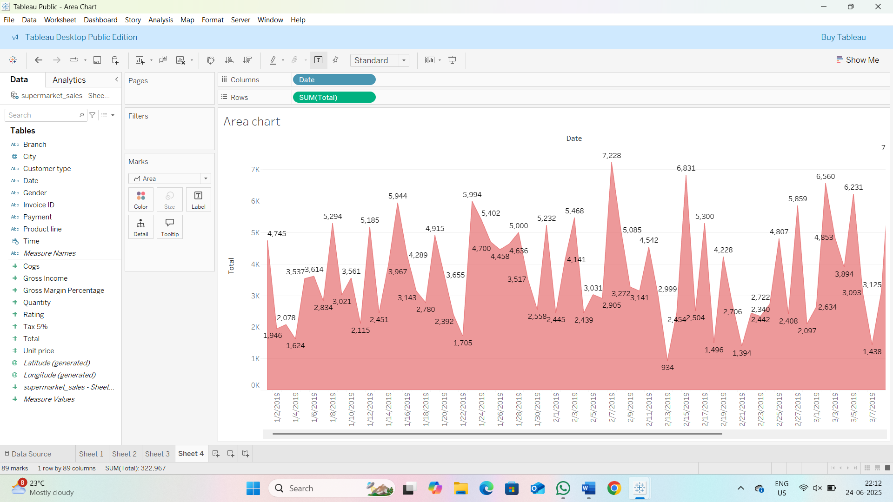

Text tables:

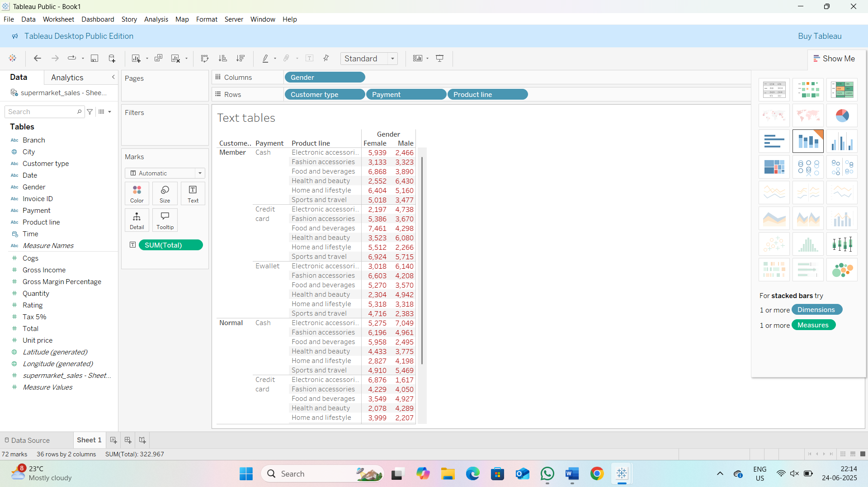

Highlighted table:

Word cloud:

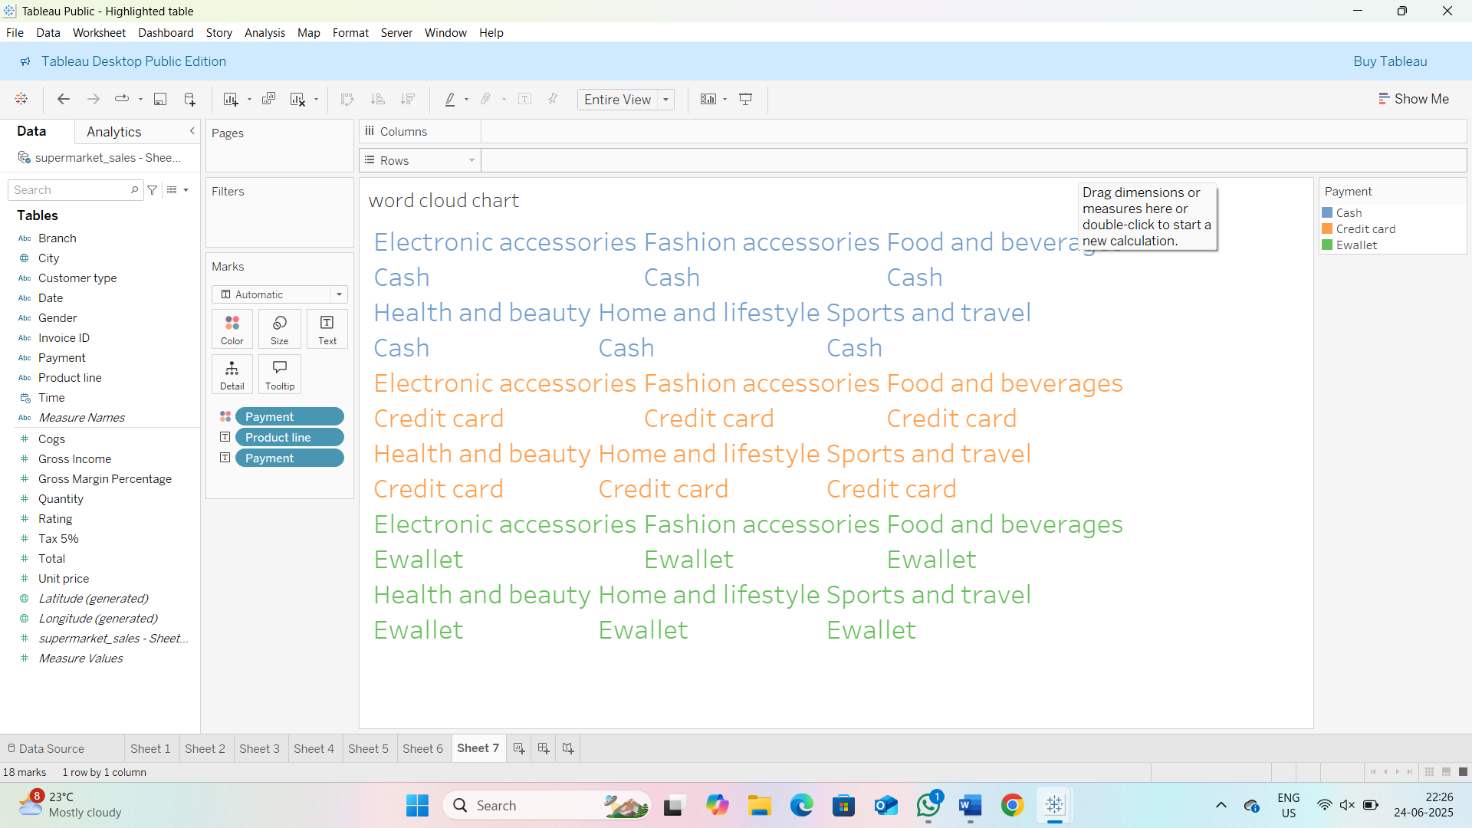

Funnel chart:

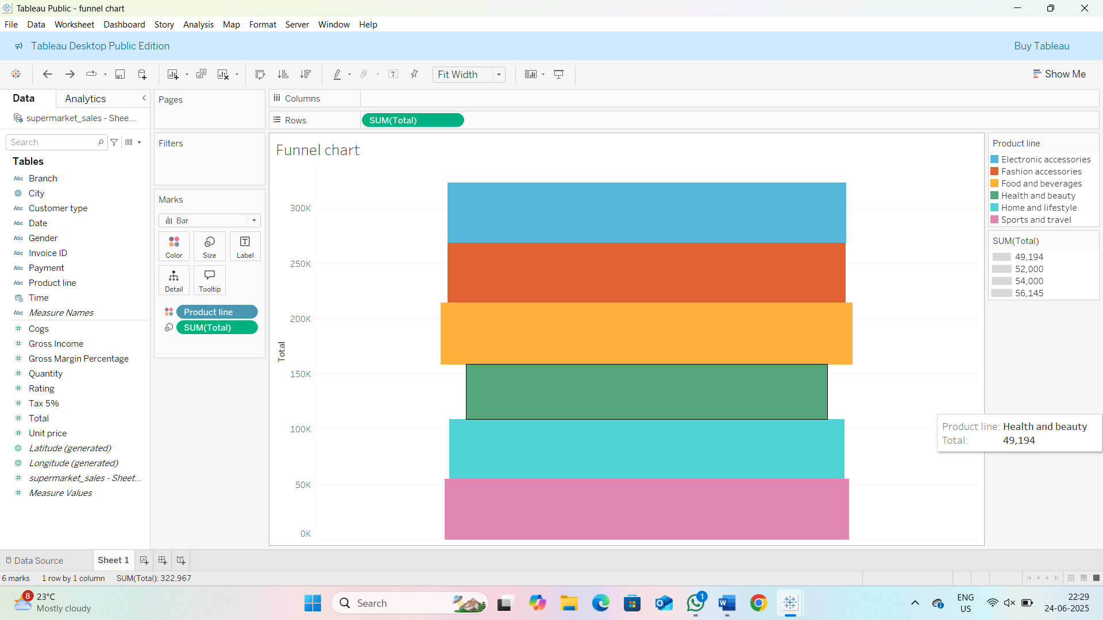

Water fall:

